Relational Databases with MySQL Week 4 Coding Assignment

**Points possible:** 70

|  |  |  |
| --- | --- | --- |
| **Category** | **Criteria** | **% of Grade** |
| **Functionality** | Does the code work? | 25 |
| **Organization** | Is the code clean and organized? Proper use of white space, syntax, and consistency are utilized. Names and comments are concise and clear. | 25 |
| **Creativity** | Student solved the problems presented in the assignment using creativity and out of the box thinking. | 25 |
| **Completeness** | All requirements of the assignment are complete. | 25 |

**Instructions:** Using a text editor of your choice, write the queries that accomplishes the objectives listed below. Take screenshots of the queries and results and paste them in this document where instructed below. Create a new repository on GitHub for this week’s assignments and push this document, with your Java project code, to the repository. Add the URL for this week’s repository to this document where instructed and submit this document to your instructor when complete.

**Coding Steps:**

Write 5 stored procedures for the employees database.

Write a description of what each stored procedure does and how to use it.

Procedures should use constructs you learned about from your research assignment and be more than just queries.

1) ______________ Concat Procedure___________________

The CONCAT_WS() function allows the user to concatenate strings of data from multiple columns. The

specified procedure is called will then return a list of concatenated results using first_name and

last_name.

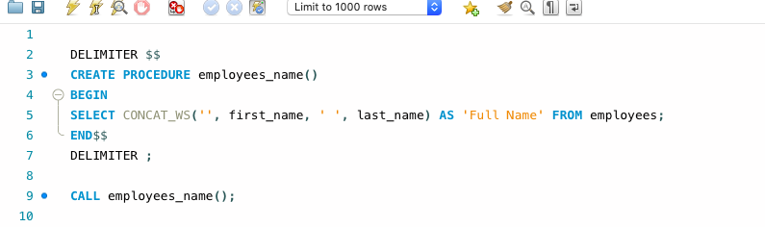

2) ______________ IN parameter___________________

The var1 function allows the user to determine the number of rows that will be returned when the procedure

is called. The var1 function is an IN parameter. This is because the calling entity must enter an

argument 'IN' to proceed with the procedure.

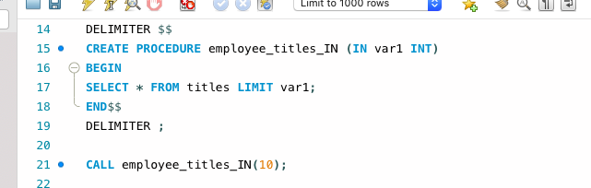

3) ______________ OUT parameter___________________

The MAX() function allows the user to determine the highest integer from a specified column when the

procedure is called. The MAX() function is an OUT parameter. This is because the calling entity

is returning a calculation 'OUT' of the procedure.

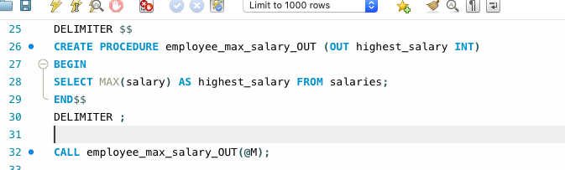

4) ______________ INOUT parameter___________________

The COUNT() function allows the user to determine the number of rows that will be returned when the

specified procedure is called. The COUNT() function is an INOUT parameter. This is because the

calling entity must enter an argument 'IN' to return the 'OUT' on the procedure.

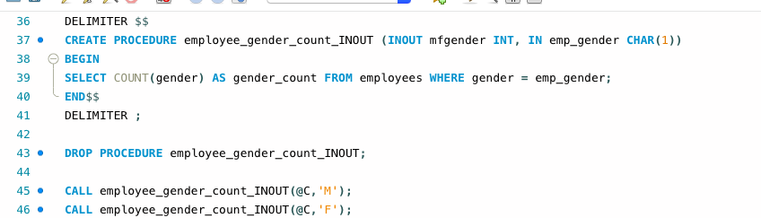

5) ____________________ Update Salary__________________________________

This procedure will take an emp_no IN and update the salary OUT. It could be used to change the database

record for when an employee gets a raise as well as a number of other uses.

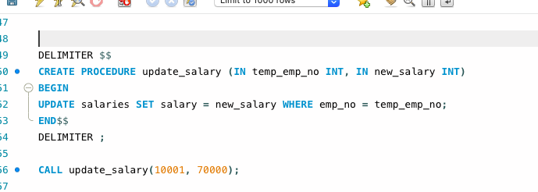

**Screenshots:**

**URL to GitHub Repository:**

**https://github.com/bryan-upton/06-17-20-Assignment.git**